First Reading: Ephesians 1:3-14
In Jesus, all of God’s plans and purposes have been made known as heaven and earth are united in Christ. Through Jesus, we have been chosen as God’s children and have been promised eternal salvation.
³Blessed be the God and Father of our Lord Jesus Christ, who has blessed us in Christ with every spiritual blessing in the heavenly places, ⁴just as he chose us in Christ before the foundation of the world to be holy and blameless before him in love. ⁵He destined us for adoption as his children through Jesus Christ, according to the good pleasure of his will, ⁶to the praise of his glorious grace that he freely bestowed on us in the Beloved. ⁷In him we have redemption through his blood, the forgiveness of our trespasses, according to the riches of his grace ⁸that he lavished on us. With all wisdom and insight ⁹he has made known to us the mystery of his will, according to his good pleasure that he set forth in Christ, ¹⁰as a plan for the fullness of time, to gather up all things in him, things in heaven and things on earth. ¹¹In Christ we have also obtained an inheritance, having been destined according to the purpose of him who accomplishes all things according to his counsel and will, ¹²so that we, who were the first to set our hope on Christ, might live for the praise of his glory. ¹³In him you also, when you had heard the word of truth, the gospel of your salvation, and had believed in him, were marked with the seal of the promised Holy Spirit; ¹⁴this is the pledge of our inheritance toward redemption as God’s own people, to the praise of his glory.

Gospel: John 1:1-18
John begins his gospel with this prologue: a hymn to the Word through whom all things were created. This Word became flesh and brought grace and truth to the world.
[¹In the beginning was the Word, and the Word was with God, and the Word was God. ²He was in the beginning with God. ³All things came into being through him, and without him not one thing came into being. What has come into being ⁴in him was life, and the life was the light of all people. ⁵The light shines in the darkness, and the darkness did not overcome it.
⁶There was a man sent from God, whose name was John. ⁷He came as a witness to testify to the light, so that all might believe through him. ⁸He himself was not the light, but he came to testify to the light. ⁹The true light, which enlightens everyone, was coming into the world.]
¹⁰He was in the world, and the world came into being through him; yet the world did not know him. ¹¹He came to what was his own, and his own people did not accept him. ¹²But to all who received him, who believed in his name, he gave power to become children of God, ¹³who were born, not of blood or of the will of the flesh or of the will of man, but of God.
¹⁴And the Word became flesh and lived among us, and we have seen his glory, the glory as of a father’s only son, full of grace and truth. ¹⁵(John testified to him and cried out, “This was he of whom I said, ‘He who comes after me ranks ahead of me because he was before me.’ ”) ¹⁶From his fullness we have all received, grace upon grace. ¹⁷The law indeed was given through Moses; grace and truth came through Jesus Christ. ¹⁸No one has ever seen God. It is God the only Son, who is close to the Father’s heart, who has made him known.
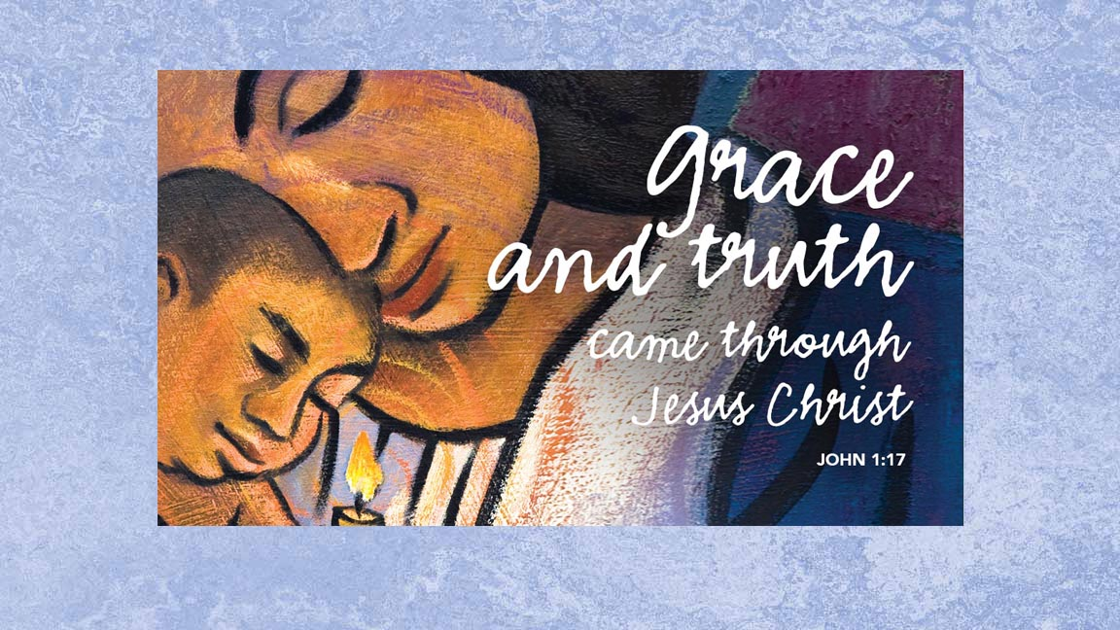
Atonement Lutheran Church
SECOND SUNDAY AFTER CHRISTMAS January 5th, 2019

gathering
Introduction to today’s worship
Within the gospel reading’s profound words lies the simple message that God is revealed in a human person. Though we may try to understand how the Word existed with God from the beginning of time, the wonder we celebrate at Christmas is that the Word continues to dwell among us. Christ comes among us in the gathered assembly, the scriptures, the waters of new birth, and the bread and the wine. Through these ordinary gifts we receive the fullness of god’s grace and truth.
Introit “The Lord Is In His Holy Temple” By: Atonement Choir
Welcome and Announcements
Confession and Forgiveness
Children’s Message
Gathering Hymn “The Bells of Christmas” (vs. 1, 3, 4) LBW Hymn #62
Greeting
Christmas Angel Medley of Praise LBW Hymn #50, #54, 71
Prayer of the Day
(ALL) Almighty God, you have filled all the earth with the light of the Word who became flesh and lived among us. By your grace upon grace empower us to reflect your light in all that we do, through Jesus Christ, our Savior and Lord, who lives and reigns with you and the Holy Spirit, one God, now and forever. Amen.
Choir Anthem “O Come And See, O Come And See The Baby” Atonement Choir
WORD
Hymn of Praise “Joy To The World” (vs. 1) LBW Hymn pg. #39
Responsive Reading: PSALM 96 (verses 1-6, 10-13)
Hymn of Praise “Joy To The World” (vs. 2) LBW Hymn pg. #39
Scripture Reading Ephesians 1:3-14
Gospel acclamation “Joy To The World” (vs. 4) LBW Hymn pg. #39
Gospel John 1:1-18
Sermon Char Gumke- Assistant to Bishop, Eastern ND Synod
Installation Hymn “Gracious Spirit, Heed Our Pleading” (vs. 1-3) WOV Hymn # 687
Nicene Creed
Installation of Rev. Linda J. Schauer
THIS WEEK:
Jan. 6th | 7:00pm | Council Meeting
Jan. 10th |  | Deadline for Annual Reports
LOOKING AHEAD:
Jan. 26th |  | Annual Meeting following worship.

UPCOMING EVENTS…
“Blessing for After” By: Jan Richardson Jackie Magnall
Installation Anthem “One Who Stands Among Us” Atonement Choir Quartet
Prayers of Intercession
Share the Peace
MEAL
Offering & Offering Song “We Are An Offering”
Offertory Prayer
The Great Thanksgiving LBW pg. #68
“Sing Choirs of Angels” (“O Come All Ye Faithful”) (vs. 3) LBW Hymn pg. #45
Distribution of Holy Communion All Are Welcome!
Communion Hymns: “Holy Child With In A Manger” WOV Hymn pg. #638
“The First Noel” LBW Hymn pg. #56
“Goods Christian Friends, Rejoice” LBW Hymn pg. #55
Post Communion Blessing and Prayer
SENDING
Sending Christmas Blessing
Choir Anthem “Will You Come and Follow Me” Atonement Choir
Dismissal
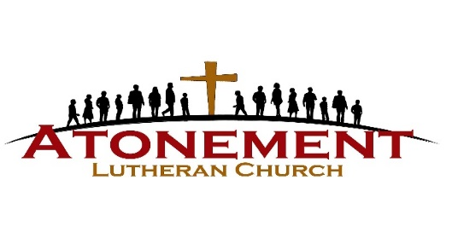

Our sympathies to family & friends of:
- JoDell Veil
(Memorial service was 01.04.20)
Our thoughts and prayers are with:
- Harold & Delores Schuh
- Paul Stahlhut- Beth Dewald’s brother

Mission of the Quarter
Hospice

FINANCIAL REPORT
Weekly Offering (12/22/19)  Christmas Eve Offering  Year End Offering  General Offering to date  General Offering needed to meet budget  --- Attendance 88--- | $ 2338.00  $ 2571.00  $ 3400.00  $ 174,258.00  $ 207,220.00

If you are interested in becoming a new member of Atonement please contact Pastor Linda at 269-1475.
Church email: atonement@daktel.com
Website: alcjamestown.org

Pastor Linda Schauer Pastor
alcpastor@daktel.com (701) 269-1475
Tonya Sletto Music
Ardina Bentz Scripture reader
Ushers
Ushers

