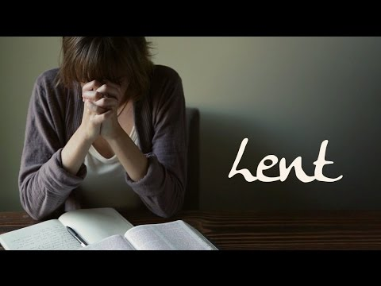
FOR NEWSLETTER ---
LENT 2020
“THE HEART BEAT OF ATONEMENT…”
Every Wednesday March 4- April 1
Meal 5:45pm – 6:30pm
Lent Worship 6:30pm- 7:15pm

COME AND BE A VITAL PART OF OUR ATONEMENT FAMILY!
All Lenten meals are a free will offering served from 5:45pm- 6:30pm (except April 1 that meal begins at 5:45pm)
All Lenten Worship Offering goes to Jamestown Salvation Army
Out Vital Signs Committee (Beth Dewald, Judy Hager, Dave Smette, Michelle Watne and Pastor Linda) will be leading our Lenten Worship at 6:30pm —and we PROMISE we will be done by 7:15pm!!!
Come –learn and experience and practice different spiritual/ prayer practices for all ages!
Come and see! Come-connect with God and connect with one another!
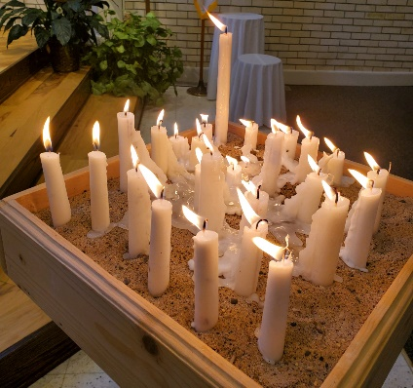
Each week we have a “Heart-Beat of Atonement Bible Verse” and a new prayer practice to try out! In Lent so often we hear of giving up something…. This year we are going to focus on adding something—learning new ways of listening, talking and connecting with God! Come and try it out! At the end of Lent you will have a “Spiritual Buffet” of different prayer practices to choose from!
Each week our service will conclude with “Pray around the Cross”
LENTEN SCHEDULE for meals and worship:
MARCH 4—Parish Fellowship to serve meal 5:45- 6:30
WORSHIP 6:30pm- 7:15pm Come and learn “DWELLING IN THE WORD”
MARCH 11- Men’s Ministry to serve meal 5:45- 6:30
WORSHIP 6:30pm-7:15pm Come and experience “CENTERING PRAYER”
MARCH 18 – Sunday School to serve meal 5:45- 6:30
WORSHIP 6:30pm- 7:15pm Come and “PRAY & COLOR”
MARCH 25--- Youth to the serve meal 5:45- 6:30
WORSHIP 6:30pm-7:15pm Come learn about “FAITH 5”
APRIL 1----“DINNER CHURCH”—COME AT 5:45- 6:30pm Worship / Holy Communion/ Special meal served by Church Council. Dave Smette to talk about His Bible studies/ Tony Sletto and Tamara Mathison to tell their story about “Bible in a Year” App! To close out our Lenten Worship on April 1 at 6:30pm- 7:15pm we have a special presentation by the Jamestown “MIME MIMISTRY”

